**UNIVERSITY OF ENGINEERING AND TECHNOLOGY, TAXILA.**

**OS LAB – 07 (Task)**

**Submitted by**

Kashaf Raheem

18-SE-28

Omega

**Submitted to**

Engr. Saba Awan

**OS LAB -07**

**TASK 1:**

Write “read” and “write” commands for the following conditions

 Read data from **standard input** and write it on **standard output.**

 Read data from the file, **given as an argument by the user** and write it on standard output.

 Read data from standard input and write it on the file **given as an argument by the user**.

**Code**

#include<stdio.h>

#include<sys/types.h>

#include<sys/stat.h>

#include<fcntl.h>

#include<stdlib.h>

#include<unistd.h>

#include<strings.h>

#include<limits.h>

int main()

{

/*

int fd;

char buff[200];

int rd=read(0,buff,100); ***//part(a)***

write(1,buff,rd);

*/

/*

char buff[200];

int fd,fd1,cd;

char filename[100];

char file1_name[100];

printf("Enter the file name to read:");

scanf("%s", filename);

fd= open(filename, O_RDWR);

if(fd==-1) ***//part(b)***

printf("Cannot open file");

else

cd=read(fd,buff,100); // to read from the user given file

write(1,buff,cd); // to write on the std output

*/

/*

int fd;

char buffer[80];

fd = open("chk",O_RDWR | O_CREAT);

if (fd != -1)

{ ***//part(c)***

printf("chk.txt file opened for read/write access\n");

read(0, buffer, 60);

printf("\n\n");

write(fd, buffer, 60);

printf("\n\n");

printf("\n %s written to myfile \n", buffer);

close (fd);

}

else

printf("error");

*/

close(fd);

}

**OUTPUT**

**Part (a)**

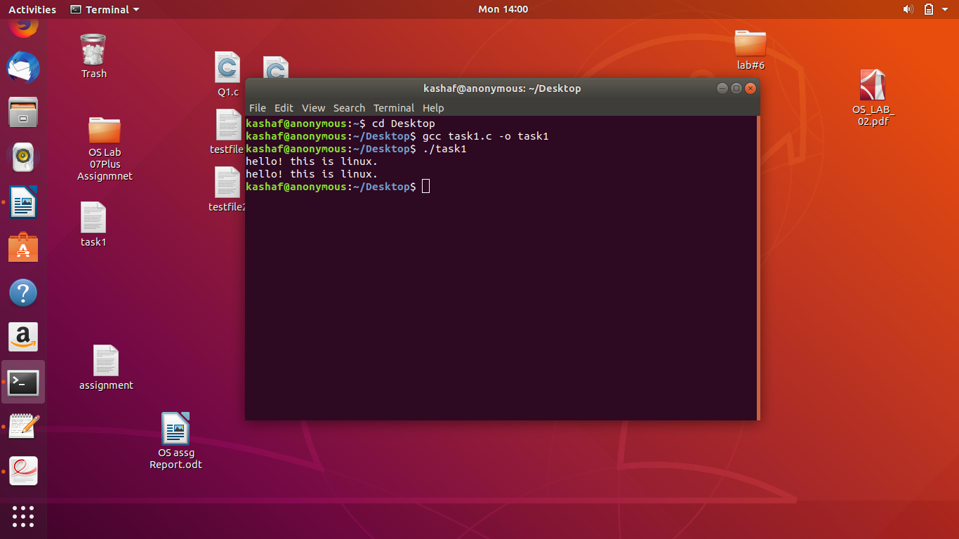

**Part(b)**

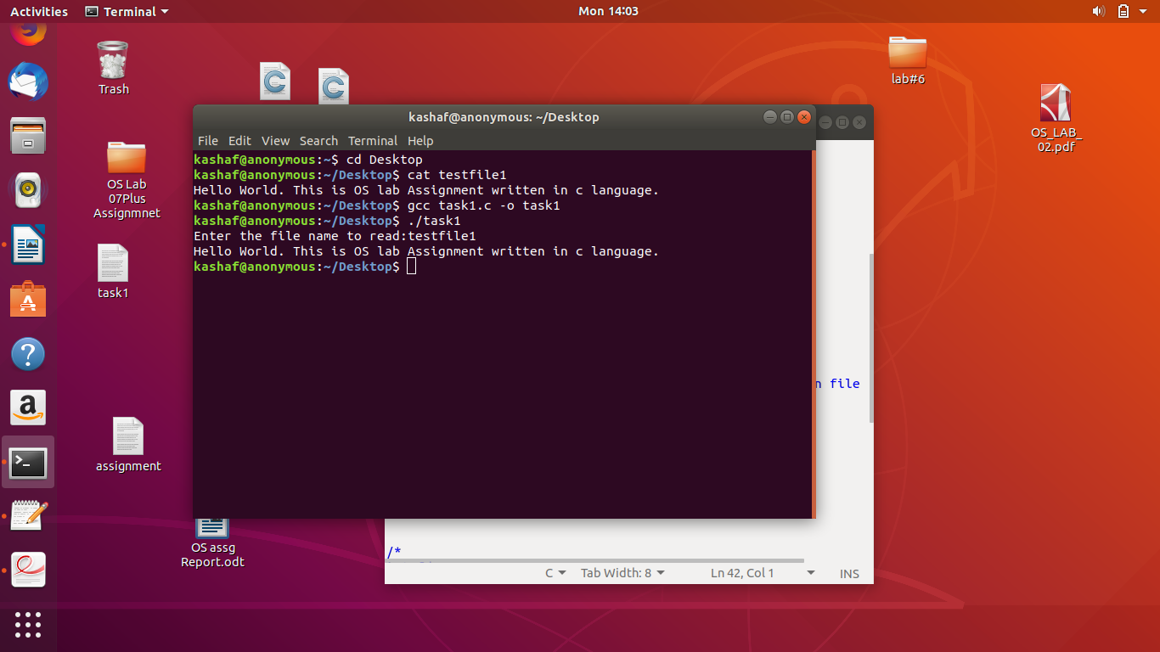

**Part(c)**

